**Ontology development - Books**

Nathan Neelis (14184249) • Information Organisation • 28-09-2022

In this assignment, an ontology is developed that includes metadata to describe a book. A book can have different subclasses of information: Genre, Author, Language, Format, Publication and Title. And each subclass could have types as well, for example, the genre class has types of different genres: Fantasy, sci-fi and educational. There are, of course, more genres than displayed in this ontology, but this exceeds the training purpose.

Except for categorizing the book’s metadata, the ontology also has relations. So the book can be ‘writtinBy’ an author, can be ‘writtenIn’ a certain language and has an ‘isGenre’ of for example fantasy.

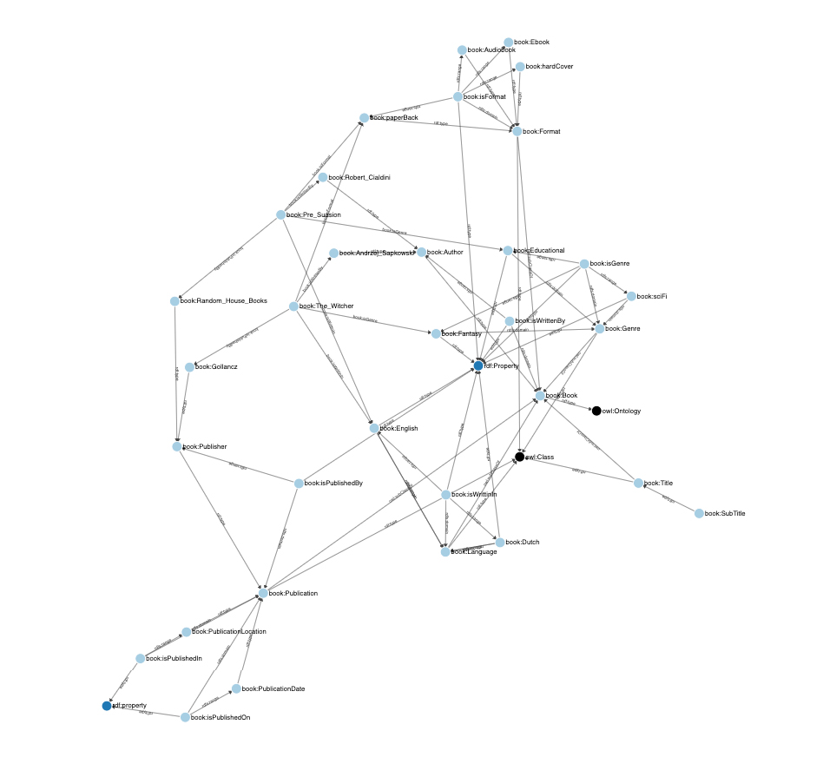To demonstrate this ontology some metadata for two different books is added. For example, The Witcher, which is a fantasy book (genre) and has a Title (The Witcher) and a subtitle (The last wish). It is written in English (language) and by Andrzej SapKowski (author). The book is a paperback (format) and is published in the UK (publish location) in 2017 (publish date) by Gollancz (publisher).

Below here the visual representation of the book's ontology.

*Fig 1. Ontology book metadata.*